Name: _________________________________ Date: ___________________________

TOPIC #2
ATOMIC STRUCTURE
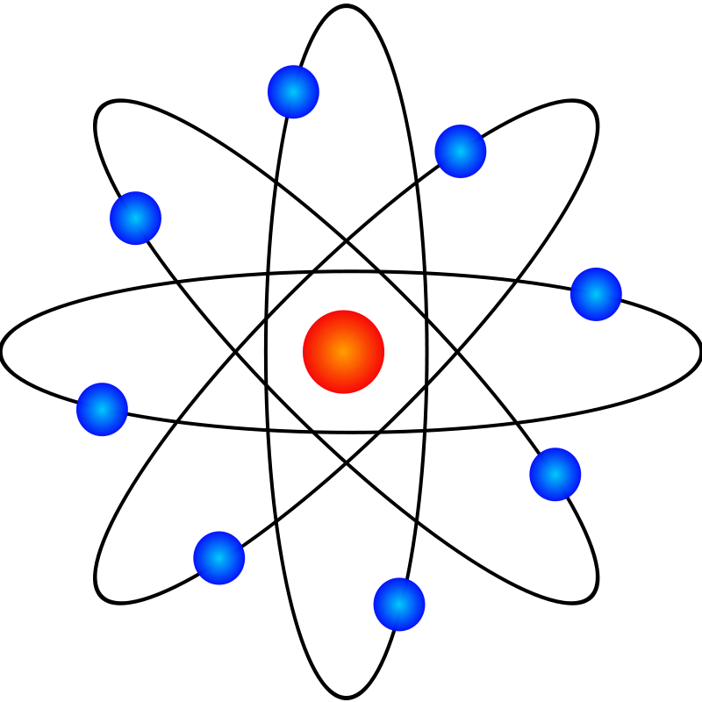

Homework Due: Monday, October 5, 2015

Exam Dates: Free Response: Wednesday, October 7
Multiple Choice: Thursday, October 8

Textbook: Chapter 4 & Chapter 5 (pgs. 102 – 157)
Topic #2 Atomic Structure Study Guide
Historical Background:
- History of atomic structure and the electrical nature of the atom and its particles involve key scientists including Dalton, Thomson, Rutherford, Bohr and others.
- One scientist’s discoveries leading the way for the next.

Parts of the Atom (Subatomic Particles) & Reference Table O
- The atom is composed of the nucleus & electron shells (principle energy levels).
- Nucleus: The nucleus is composed of nucleons.
  - Nucleons: all particles in the nucleus (protons & neutrons)
    - Protons: positively-charged, found in nucleus, mass = 1 AMU
    - Neutrons: neutrally-charged, found in nucleus, mass = 1 AMU
- Shells/Principle Energy Levels (PELs):
  - Electrons- negatively-charge, orbit around the nucleus, has very little mass (1/1836 of a proton or 1/1836 amu)
- Net (overall) charge of an atom is 0 (neutral)
- Nuclear charge: based on the # of protons in the nucleus
- Atomic number = # of protons and in a neutral atom (also the # of electrons)
- Atomic mass/ Mass Number = # of protons + # of neutrons
- Calculating the # of neutrons use the formula: Atomic Mass – Atomic Number
- Isotopes are atoms of the same element with different mass (different # of neutrons); calculate average isotopic mass using the weighted average of the naturally occurring isotopes
- Kernel: symbol of element representing the nucleus and all electrons except the valence electrons
- Atomic and Ionic and Radii
  - Metals tend to lose electrons, become positive ions with a smaller radius than its atom
  - Non-metals tend to gain electrons, become negative ions with a larger radius than its atom
- Radioactive Decay Particles: Look for decay particles on chart O
  - Alpha (helium nucleus)
  - Beta (electron)
  - Gamma
- Separating nuclear decay particle emission
- Alpha - positive particle deflects toward negative pole
- Beta – negative particle deflects toward positive pole
- Gamma – neutral particle unaffected by the charge of the poles

Models of the Atom (Subatomic Particles) & Reference Table O
- John Dalton: The Billiard Ball/Cannonball Model
- J.J. Thomson: The Plum Pudding Model
- Ernest Rutherford: The Planetary Model
- Niels Bohr: The Bohr Model
- Heisenberg & Schrodinger: The Wave Mechanical Model/The Electron Cloud Model/The Modern Atomic Theory
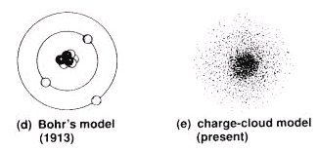
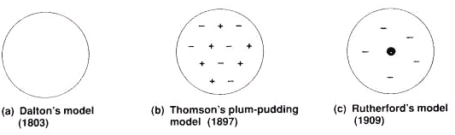

Arrangement of Electrons Outside the Nucleus
- Ground State: electrons occupy the lowest available energy levels.
- Excited State: the condition that exists when the electrons of an atom occupy higher energy levels while lower energy levels are vacant.
- Spectral lines
  - Absorption of energy causes electrons to jump to higher levels
  - Emission of energy occurs when electrons fall back to their original location

Modern Atomic Structure Theory
- Electron Cloud Model of the atom and understanding all notations
    - Principal energy level (PEL)- All sublevels with the same coefficient (big number in front)
    - Sublevels- Any letter after a coefficient (s,p,d,f)-representing the area of probability of locating an electron.
    - Orbital –a region in an atom in which an electron of particular amount of energy is probably located.

Coefficient represents PEL→ 2 s 3 ← superscript represents the # of electrons
Orbital Diagrams
  - Remember the sublevels Smart People Don’t Fail
  - Remember how to fill the orbitals of a particular sublevel; put an ↑ in each orbital before placing the second electron - up up up (↑↑↑)… then down down down (↓↓↓) …
  - Look for the words …. Half filled, occupied and completely filled
  - Electrons fill shells from lowest to highest energy.
- Hunds rule/Octet rule: stable valence electron configuration of eight electrons

SUMMARY
Principal Energy Level | Sublevel | Obitals | # of electrons
1 | s | 1 | 2
2 | s, p | 1, 3 | 2, 6
3 | s, p, d | 1, 3, 5 | 2, 6, 10
4 | s, p, d, f | 1, 3, 5, 7 | 2, 6, 10, 14

Table S
- Ionization energy: amount of energy needed to remove the most loosely bound electron from a neutral atom.
- Electronegativity: a measure of the attraction of a nucleus for a bonded electron.

Key Vocabulary
Atom excited state neutron valence electron
Atomic mass ground state nucleus valence shell
Atomic mass unit isotope orbital spectral lines
Atomic number mass number proton nucleons
Electron neutron element
Nucleons PEL ion

Topic # 6 Atomic Structure Homework

Section A: The Atom
- Use your textbook to define the term “atom”:
An atom is the smallest particle of an element that retains its identity in a chemical reaction.

- Complete the Subatomic Particles chart below (See textbook pg. 107.)
Particle | Symbol | Charge | Actual Mass (g) | Location of Particle | Relative Mass  (amu)
Proton | p⁺¹ | +1 | 1.6726 X 10⁻²⁴ | Inside nucleus | 1 amu
Neutron | n⁰ | 0 | 1.6749 X 10⁻²⁴ | Inside nucleus | 1 amu
Electron | e⁻¹ | -1 | 9.108 X 10⁻²⁸ | Electron cloud surrounding nucleus | 1/1840 amu  (negligible)

- What is the difference between “net charge” and “nuclear charge”?
Net Charge | Nuclear Charge
Net charge is the total/overall charge of the atom. All atoms are neutral because protons equal electrons. Ions have a net charge which can be calculated by subtracting the number of electrons from the number of protons:  # of protons - # of electrons = net charge | Nuclear charge is the total/overall charge of the NUCLEUS of an atom. Nuclear charge is ALWAYS positive in sign, and equal in magnitude to the number of protons residing in the nucleus.  (+) # of protons = nuclear charge

- Complete the chart below:
Symbol | Atomic number | Atomic mass/  Mass number | Number of protons | Number of electrons | Number of neutrons | Atomic Charge | Nuclear Charge
H | 1 | 1 | 1 | 1 | 0 | 0 | +1
H | 1 | 3 | 1 | 1 | 2 | 0 | +1
Pd | 46 | 107 | 46 | 46 | 61 | 0 | +46
B | 5 | 11 | 5 | 5 | 6 | 0 | +5
Pb | 82 | 208 | 82 | 82 | 126 | 0 | +82
Tc | 43 | 97 | 43 | 43 | 54 | 0 | +43

Textbook Page 118:
#30: Atomic number corresponds to the number of protons. Mass number represents the total number of protons and neutrons.

Textbook Page 122:
#45: positive

#47: It has equal number of positively-charged protons and negatively-charged electrons.

Section B: Radioactive Decay Particles
- Label the rays at A, B and C as radiation passes through a magnetic field.
+ A) Beta (deflected toward positive pole)

B) Gamma (no deflection)

_ C) Alpha (deflected toward negative pole)

- Complete the chart below: (Use Reference Table O.)
Decay Particle | Notation | Greek Symbol | Charge of particle
Alpha | ⁴He  ² | α | +
Beta | ⁰e  ⁻¹ | β | -
Gamma | ⁰γ  ⁰ | γ | 0

- Which nuclear emission, moving through an electric field would be deflected toward the positive electrode? Explain why.
A beta particle because it has a negative charge and opposite charges attract.

- The structure of an alpha particle is similar to what atom or element? What is the difference between the two?
An alpha particle is similar to Helium. The difference is that Helium has 2 electrons while an alpha particle does not.

Section C: Models of the Atom
- Draw diagrams of Thomson models of a boron atom and a fluorine
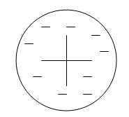
atom.

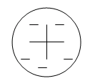

Boron Fluorine

- Describe the limitation with Rutherford’s model of the atom.
It did not explain what was happening to the electrons, just that they were outside the nucleus.

Textbook Page 109
#13: Rutherford’s Gold Foil Experiment
Expected Outcome:  Rutherford expected that all the alpha particles would pass straight through with little deflection. | Actual Outcome:  Most alpha particles pass straight through, but some particles were deflected at very large angles – and some even bounced back.

#14: The great majority of the alpha particles pass straight through the gold foil.

#15: Rutherford’s Atomic Model vs. Thomson’s Atomic Model
Rutherford:  Described the atom as having a positively-charged, dense nucleus that is tiny compared to the atom as a whole. | Thomson:  Electrons are stuck in a chunk of positive charge.

Textbook Page 152:
#27: He used existing ideas about the atom to propose that electrons move around the nucleus like planets move around the sun.
Pearson SuccessNet On-Line
Go to: Chapter 4 → Chapter-Level Activities → Ch. 4 Directed Virtual Lab: Rutherford’s Experiment. Answer all questions and submit.
Go to: Chapter 4 → Chapter-Level Activities → Ch. 4.2 Kinetic Art – Cathode Ray. Answer all questions and submit.

Section D: Ions
- Use your textbook to define the term “ion”:
An ion is an atom or group of atoms that has a positive or negative charge.

- Complete the table for the composition of the following ions.
Symbol | Na+1 | Be+2 | As-3 | F-1
Ion charge | 1+ | +2 | 3- | -1
# of protons | 11 | 4 | 33 | 9
# of neutrons | 12 | 5 | 42 | 10
# of electrons | 10 | 2 | 36 | 10
Atomic # | 11 | 4 | 33 | 9
Mass Number | 23 | 9 | 75 | 19
Section E: Isotopes

- Cobolt-60 is used in the radiation therapy to treat cancer. How many neutrons does each cobalt-60 atom contain? 33 neutrons
What is a disadvantage to using radioactive isotopes in medical procedures? Radioactive isotopes often have long half-lives and

- Calcium has five stable isotopes. How do these isotopes differ from
one another? How are they similar?
Difference: # of neutrons
Similar: # of protons, # of electrons

Textbook Page 116:
#4.3 (Interpret Data)
a) oxygen-16
b) Helium hs two isotopes, helium-3 and helium-4. The atomic mass of helium is very close to 4 amu, therefore helium-4 must be most abundant.

Textbook Page 122:

#52: mass numbers, atomic masses, number of neutrons, relative abundance

#64: Calculating the average atomic mass of lead: 207 amu

Textbook Page 156
#106: The value 35.453 amu is a weighted average. Its calculation is based on the percentage natural abundance of two isotopes, chlorine-35 and chlorine-37.

Section F: Electrons in Atoms

- Fill in the information for the element Sulfur
- Nuclear charge: +16
- Number of neutrons: 16
- Symbol of element: S
- Electron configuration (from Periodic Table): 2-8-6
- Representative electron configuration (ex: 1s²2s²…): 1s²2s²2p⁶3s²3p⁴
- Noble gas configuration: [Ne]3s²3s⁴
- P.E.L. # of valence energy shell: 3
- Number of valence electrons: 6
- Possible oxidation numbers that will obtain an octet: -2, +6… (other oxidation states possible)
- Fill in the orbital notation below:

↑↓ ↑↓ ↑↓ ↑↓ ↑↓ ↑↓ ↑↓ ↑ ↑ ___ ___ ___ ___ ___ ___ ___ ___ ___
1s 2s 2p 3s 3p 3d 4s 4p

- Number of occupied sublevels: 5
- Number of half-filled orbitals: 2
- Number of completely filled principle energy levels: 2
- Kernel of this atom includes: 16 protons, 10 electrons (valence not included) and 16 neutrons
- A possible excited state electron configuration: 2-7-7 (other answers possible)
- Electron dot diagram
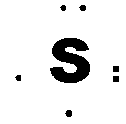

Textbook Page 132:

#1: An electron is found only in specific circular paths or orbits around the nucleus.

#2: It determines the allowed energy levels an electron can have and the likelihood of finding an electron in various locations around the nucleus.

#3: The sublevels have different shapes.

#4: By losing or gaining just the right amount of energy (quanta)

Textbook Page 152:
#31: a region in space around the nucleus in which there is a high probability of finding an electron.

#35: Electrons occupy the lowest possible energy levels. An atomic orbigtal can hold at most two electrons. One electron occupies each of a set of orbitals with equal energies befor3e any pairing of electrons occurs.

#40:
a) 1s²2s²2p b) 1s²2s²2p⁵ c) 1s²2s²2p⁶3s² d) 1s²2s²2p⁶3s²3p⁶3d¹⁰4s²4p⁶

#56:
a) Ar b) Ru c) Gd

#61: 2

Textbook Page 154
#73: An orbit confines the electron to a fixed circular path around the nucleus; an orbital is a region around the nucleus in which electrons are likely to be found.

#77:
- What’s wrong with the diagram?
Electrons in 2p boxes should not be paired. There should be one electron in each box.
Correct Orbital Diagram:

↑↓ ↑↓ ↑ ↑ ↑
1s 2s 2p

- What’s wrong with the diagram?
Magnesium has 12 electrons. Two more electrons need to be added to 3s.

Correct Orbital Diagram:
↑↓ ↑↓ ↑↓ ↑↓ ↑↓ ↑↓
1s 2s 2p 3s

Section G: Bright Line Spectra
- Use your textbook to define the following terms:
  - Ground state: The lowest possible energy of an atom described by quantum mechanics.
  - Excited state: Excitation of the electron by absorbing energy raises the atom to an excited state, which is a higher energy level than usual.

- Write the electron configuration for potassium in the ground state: 2-8-8-1
Write an electron configuration for potassium in the excited state: 2-8-7-2

- Based on the Bright Line Emission Spectra below, answer the questions that follow.
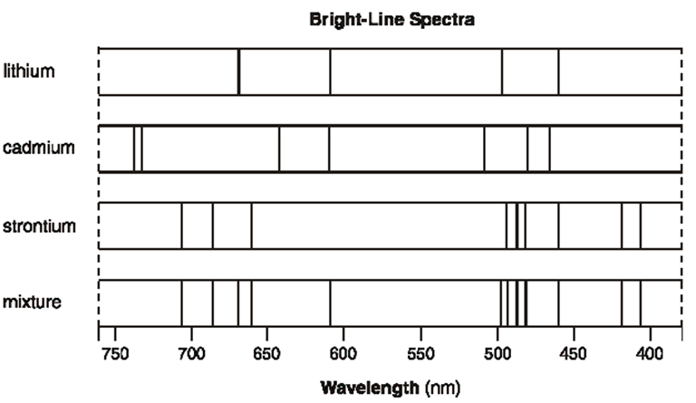

- Identify all elements in the mixture. Sr, Li
- Explain, in terms of both electrons and energy, how the bright-line spectrum of an element is produced.
The bright line spectrum of an element is produced when electrons return to the ground state from the excited state. Excess energy is released as photons of light as electrons go from a higher energy level to a lower energy level.

Textbook Page 141:

#15: 2.00 x 10⁻⁵ m
Does this radiation have a longer or
shorter wavelength than red light?
longe

Reading in the Sciences Assignment
Answer the questions after reading the article entitled "Making New Elements How Scientists Create Superheavy Atoms," Popular Science, May 2013.

1. What is so unusual and significant about creating the element 119?
Element 119 would add a new row to the Periodic Table.

2. Summarize the 4-step "recipe" for creating element 119.
1. Accelerate particles into a target
2. Collide the particles in the beam with the particles in the target
3. Separate the newly formed element atoms from the other particles
4. Detect atoms of the newly formed element

3. Name the 2 elements that "smash" together to create element 119.
titanium and berkelium

4. What is an alpha particle?
2 protons and 2 neutrons

5. Why do scientists need to detect alpha particles?
Element 119 gives off alpha particles, so detecting alpha particles proves the existence
of element 119

6. What does I.U.P.A.C. stand for?
International Union of Pure and Applied Chemistry

7. Complete the atomic symbol for element 119 with the appropriate information.
Uue
296
119

atomic mass
atomic symbol/kernel

atomic
number

8. To date, have the scientists been successful in detecting the presence of element 119?
(Answers may vary)

